SQL Server Database Missing Index Email Report (DMVs)
https://gallery.technet.microsoft.com/scriptcenter/SQL-Server-Database-0aef26fd
SQL Server Database Missing Index Email Report (DMVs)
Use sp_send_dbmail stored procedure from msdb database to send missing index report (DMVs) to email weekly/monthly.
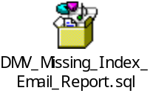
Requirements:
@dbname - Database Name
@profile_name - Name of an existing Database Mail Profile
To check all profiles on the instance use following script
EXECUTE msdb.dbo.sysmail_help_profileaccount_sp;

@recipients - Is a semicolon-delimited list of e-mail addresses to send the message to, varchar(max)
Script usage:
Example how to use this script using SQL Agent Job
Create New SQL Agent Job and add the script
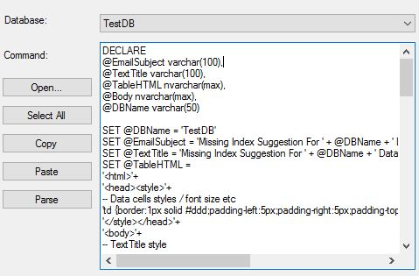

Resolving possible issues:
Error: SELECT failed because the following SET options have incorrect settings: 'QUOTED_IDENTIFIER'
Solution: Adding SET QUOTED_IDENTIFIER ON before the script in SQL Agent Job Step should solve the problem.
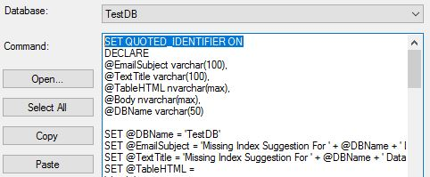
Additional explanation:
SET QUOTED_IDENTIFIERS ON and OFF settings
If you have SET QUOTED_IDENTIFIERS ON: Characters Enclosed within double quotes are treated as Identifiers
If you have SET QUOTED_IDENTIFIERS OFF: Characters Enclosed within double quotes are treated as Literals
Find all the objects which are created with SET QUTOED_IDENTIFIERS ON or OFF (1 or 0)
SELECT OBJECT_NAME(object_id)
FROM sys.sql_modules
WHERE uses_quoted_identifier = 1

